UNIT-II

GAME :-

* In previous topics, we have studied the search strategies which are only associated with a single agent that aims to find the solution which often expressed in the form of a sequence of actions.
* But, there might be some situations where more than one agent is searching for the solution in the same search space, and this situation usually occurs in game playing.
* The environment with more than one agent is termed as **multi-agent environment**, in which each agent is an opponent of other agent and playing against each other. Each agent needs to consider the action of other agent and effect of that action on their performance.
* So, **Searches in which two or more players with conflicting goals are trying to explore the same search space for the solution, are called adversarial searches, often known as Games**.
* Games are modeled as a Search problem and heuristic evaluation function, and these are the two main factors which help to model and solve games in AI.

Types of Games in AI:

|  |  |  |
| --- | --- | --- |
|  | **Deterministic** | **Chance Moves** |
| **Perfect information** | Chess, Checkers, go, Othello | Backgammon, monopoly |
| **Imperfect information** | Battleships, blind, tic-tac-toe | Bridge, poker, scrabble, nuclear war |

* **Perfect information:** A game with the perfect information is that in which agents can look into the complete board. Agents have all the information about the game, and they can see each other moves also. Examples are Chess, Checkers, Go, etc.
* **Imperfect information:** If in a game agents do not have all information about the game and not aware with what's going on, such type of games are called the game with imperfect information, such as tic-tac-toe, Battleship, blind, Bridge, etc.
* **Deterministic games:** Deterministic games are those games which follow a strict pattern and set of rules for the games, and there is no randomness associated with them. Examples are chess, Checkers, Go, tic-tac-toe, etc.
* **Non-deterministic games:** Non-deterministic are those games which have various unpredictable events and has a factor of chance or luck. This factor of chance or luck is introduced by either dice or cards. These are random, and each action response is not fixed. Such games are also called as stochastic games.  
  Example: Backgammon, Monopoly, Poker, etc.

### Formalization of the problem:

**A game can be defined as a type of search in AI which can be formalized of the following elements:**

* **Initial state:** It specifies how the game is set up at the start.
* **Player(s):** It specifies which player has moved in the state space.
* **Action(s):** It returns the set of legal moves in state space.
* **Result(s, a):** It is the transition model, which specifies the result of moves in the state space.
* **Terminal-Test(s):** Terminal test is true if the game is over, else it is false at any case. The state where the game ends is called terminal states.
* **Utility(s, p):** A utility function gives the final numeric value for a game that ends in terminal states s for player p. It is also called payoff function. For Chess, the outcomes are a win, loss, or draw and its payoff values are +1, 0, ½. And for tic-tac-toe, utility values are +1, -1, and 0.

Game tree:

A game tree is a tree where nodes of the tree are the game states and Edges of the tree are the moves by players. Game tree involves initial state, actions function, and result Function.

**Example: Tic-Tac-Toe game tree:**

The following figure is showing part of the game-tree for tic-tac-toe game. Following are some key points of the game:

* There are two players MAX and MIN.
* Players have an alternate turn and start with MAX.
* MAX maximizes the result of the game tree
* MIN minimizes the result.

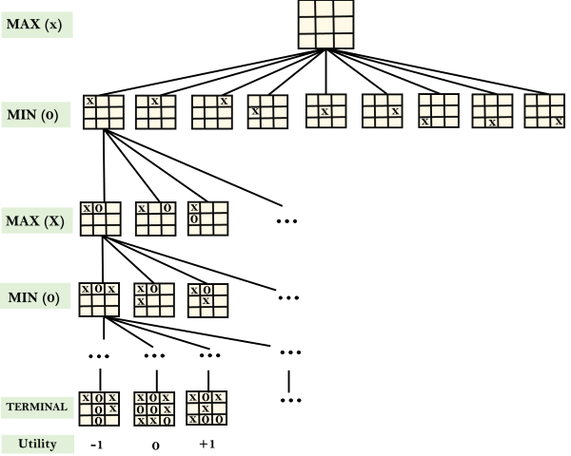

**Example Explanation:**

* From the initial state, MAX has 9 possible moves as he starts first. MAX place x and MIN place o, and both player plays alternatively until we reach a leaf node where one player has three in a row or all squares are filled.
* Both players will compute each node, minimax, the minimax value which is the best achievable utility against an optimal adversary.
* Suppose both the players are well aware of the tic-tac-toe and playing the best play. Each player is doing his best to prevent another one from winning. MIN is acting against Max in the game.
* So in the game tree, we have a layer of Max, a layer of MIN, and each layer is called as **Ply**. Max place x, then MIN puts o to prevent Max from winning, and this game continues until the terminal node.
* In this either MIN wins, MAX wins, or it's a draw. This game-tree is the whole search space of possibilities that MIN and MAX are playing tic-tac-toe and taking turns alternately.

Hence adversarial Search for the minimax procedure works as follows:

* It aims to find the optimal strategy for MAX to win the game.
* It follows the approach of Depth-first search.
* In the game tree, optimal leaf node could appear at any depth of the tree.
* Propagate the minimax values up to the tree until the terminal node discovered.

In a given game tree, the optimal strategy can be determined from the minimax value of each node, which can be written as MINIMAX(n). MAX prefer to move to a state of maximum value and MIN prefer to move to a state of minimum value then:

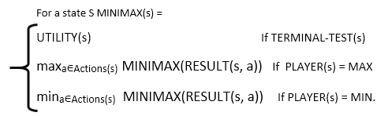

# Mini-Max Algorithm in Artificial Intelligence

* Mini-max algorithm is a recursive or backtracking algorithm which is used in decision-making and game theory. It provides an optimal move for the player assuming that opponent is also playing optimally.
* Mini-Max algorithm uses recursion to search through the game-tree.
* Min-Max algorithm is mostly used for game playing in AI. Such as Chess, Checkers, tic-tac-toe, go, and various tow-players game. This Algorithm computes the minimax decision for the current state.
* In this algorithm two players play the game, one is called MAX and other is called MIN.
* Both the players fight it as the opponent player gets the minimum benefit while they get the maximum benefit.
* Both Players of the game are opponent of each other, where MAX will select the maximized value and MIN will select the minimized value.
* The minimax algorithm performs a depth-first search algorithm for the exploration of the complete game tree.
* The minimax algorithm proceeds all the way down to the terminal node of the tree, then backtrack the tree as the recursion.

Working of Min-Max Algorithm:

* The working of the minimax algorithm can be easily described using an example. Below we have taken an example of game-tree which is representing the two-player game.
* In this example, there are two players one is called Maximizer and other is called Minimizer.
* Maximizer will try to get the Maximum possible score, and Minimizer will try to get the minimum possible score.
* This algorithm applies DFS, so in this game-tree, we have to go all the way through the leaves to reach the terminal nodes.
* At the terminal node, the terminal values are given so we will compare those value and backtrack the tree until the initial state occurs. Following are the main steps involved in solving the two-player game tree:

**Step-1:** In the first step, the algorithm generates the entire game-tree and apply the utility function to get the utility values for the terminal states. In the below tree diagram, let's take A is the initial state of the tree. Suppose maximizer takes first turn which has worst-case initial value =- infinity, and minimizer will take next turn which has worst-case initial value = +infinity.

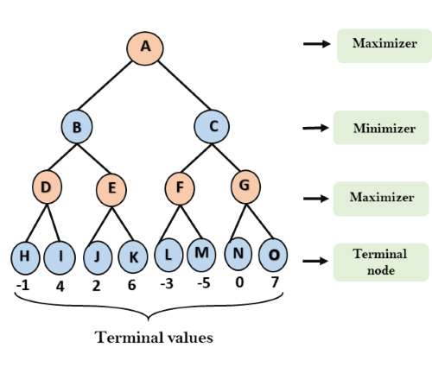

**Step 2:** Now, first we find the utilities value for the Maximizer, its initial value is -∞, so we will compare each value in terminal state with initial value of Maximizer and determines the higher nodes values. It will find the maximum among the all.

* For node D         max(-1,- -∞) => max(-1,4)= 4
* For Node E         max(2, -∞) => max(2, 6)= 6
* For Node F         max(-3, -∞) => max(-3,-5) = -3
* For node G         max(0, -∞) = max(0, 7) = 7

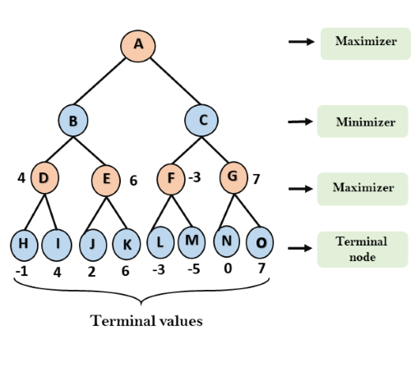

**Step 3:** In the next step, it's a turn for minimizer, so it will compare all nodes value with +∞, and will find the 3rd layer node values.

* For node B= min(4,6) = 4
* For node C= min (-3, 7) = -3

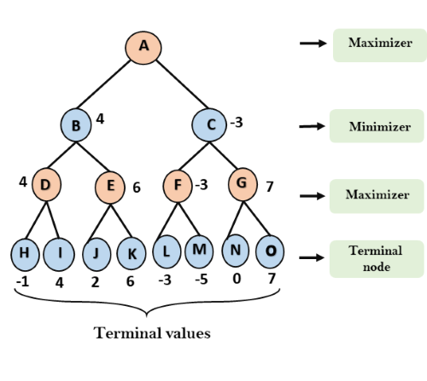

**Step 4:** Now it's a turn for Maximizer, and it will again choose the maximum of all nodes value and find the maximum value for the root node. In this game tree, there are only 4 layers, hence we reach immediately to the root node, but in real games, there will be more than 4 layers.

* For node A max(4, -3)= 4

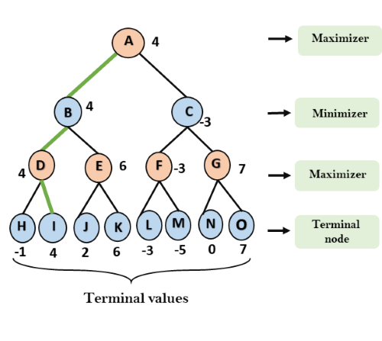

That was the complete workflow of the minimax two player game.

Properties of Mini-Max algorithm:

* **Complete-** Min-Max algorithm is Complete. It will definitely find a solution (if exist), in the finite search tree.
* **Optimal-** Min-Max algorithm is optimal if both opponents are playing optimally.
* **Time complexity-** As it performs DFS for the game-tree, so the time complexity of Min-Max algorithm is **O(bm)**, where b is branching factor of the game-tree, and m is the maximum depth of the tree.
* **Space Complexity-** Space complexity of Mini-max algorithm is also similar to DFS which is **O(bm)**.

Limitation of the minimax Algorithm:

The main drawback of the minimax algorithm is that it gets really slow for complex games such as Chess, go, etc. This type of games has a huge branching factor, and the player has lots of choices to decide. This limitation of the minimax algorithm can be improved from **alpha-beta pruning** which we have discussed in the next topic.

# Alpha-Beta Pruning

* Alpha-beta pruning is a modified version of the minimax algorithm. It is an optimization technique for the minimax algorithm.
* As we have seen in the minimax search algorithm that the number of game states it has to examine are exponential in depth of the tree. Since we cannot eliminate the exponent, but we can cut it to half. Hence there is a technique by which without checking each node of the game tree we can compute the correct minimax decision, and this technique is called **pruning**. This involves two threshold parameter Alpha and beta for future expansion, so it is called **alpha-beta pruning**. It is also called as **Alpha-Beta Algorithm**.
* Alpha-beta pruning can be applied at any depth of a tree, and sometimes it not only prune the tree leaves but also entire sub-tree.
* The two-parameter can be defined as:
  1. **Alpha:** The best (highest-value) choice we have found so far at any point along the path of Maximizer. The initial value of alpha is **-∞**.
  2. **Beta:** The best (lowest-value) choice we have found so far at any point along the path of Minimizer. The initial value of beta is **+∞**.
* The Alpha-beta pruning to a standard minimax algorithm returns the same move as the standard algorithm does, but it removes all the nodes which are not really affecting the final decision but making algorithm slow. Hence by pruning these nodes, it makes the algorithm fast.

Condition for Alpha-beta pruning:

The main condition which required for alpha-beta pruning is:

1. α>=β

Key points about alpha-beta pruning:

* The Max player will only update the value of alpha.
* The Min player will only update the value of beta.
* While backtracking the tree, the node values will be passed to upper nodes instead of values of alpha and beta.
* We will only pass the alpha, beta values to the child nodes.

Working of Alpha-Beta Pruning:

Let's take an example of two-player search tree to understand the working of Alpha-beta pruning

**Step 1:** At the first step the, Max player will start first move from node A where α= -∞ and β= +∞, these value of alpha and beta passed down to node B where again α= -∞ and β= +∞, and Node B passes the same value to its child D.

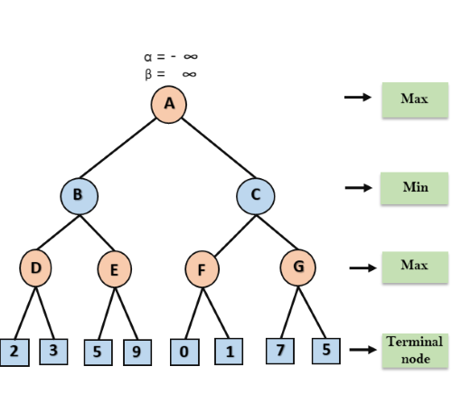

**Step 2:** At Node D, the value of α will be calculated as its turn for Max. The value of α is compared with firstly 2 and then 3, and the max (2, 3) = 3 will be the value of α at node D and node value will also 3.

**Step 3:** Now algorithm backtrack to node B, where the value of β will change as this is a turn of Min, Now β= +∞, will compare with the available subsequent nodes value, i.e. min (∞, 3) = 3, hence at node B now α= -∞, and β= 3.

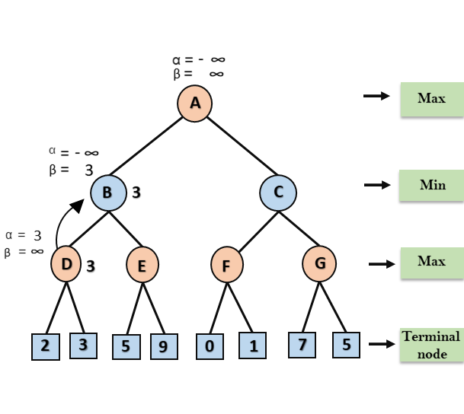

In the next step, algorithm traverse the next successor of Node B which is node E, and the values of α= -∞, and β= 3 will also be passed.

**Step 4:** At node E, Max will take its turn, and the value of alpha will change. The current value of alpha will be compared with 5, so max (-∞, 5) = 5, hence at node E α= 5 and β= 3, where α>=β, so the right successor of E will be pruned, and algorithm will not traverse it, and the value at node E will be 5.

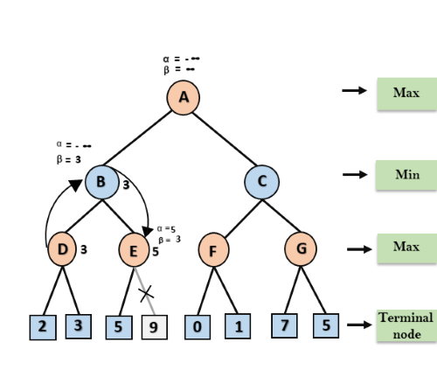

**Step 5:** At next step, algorithm again backtrack the tree, from node B to node A. At node A, the value of alpha will be changed the maximum available value is 3 as max (-∞, 3)= 3, and β= +∞, these two values now passes to right successor of A which is Node C.

At node C, α=3 and β= +∞, and the same values will be passed on to node F.

**Step 6:** At node F, again the value of α will be compared with left child which is 0, and max(3,0)= 3, and then compared with right child which is 1, and max(3,1)= 3 still α remains 3, but the node value of F will become 1.

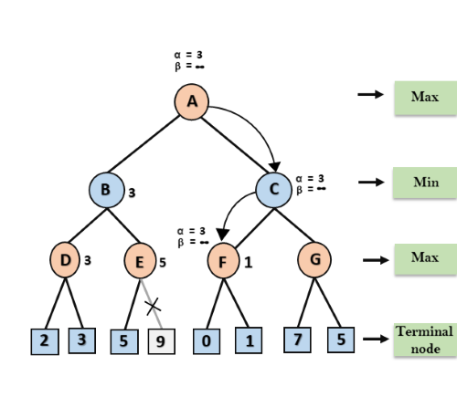

**Step 7:** Node F returns the node value 1 to node C, at C α= 3 and β= +∞, here the value of beta will be changed, it will compare with 1 so min (∞, 1) = 1. Now at C, α=3 and β= 1, and again it satisfies the condition α>=β, so the next child of C which is G will be pruned, and the algorithm will not compute the entire sub-tree G.

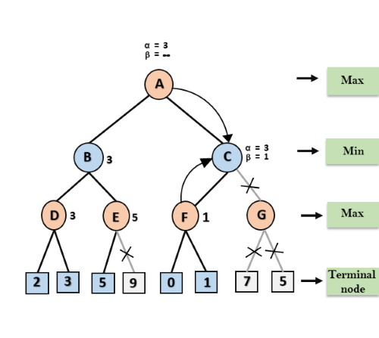

**Step 8:** C now returns the value of 1 to A here the best value for A is max (3, 1) = 3. Following is the final game tree which is the showing the nodes which are computed and nodes which has never computed. Hence the optimal value for the maximizer is 3 for this example.

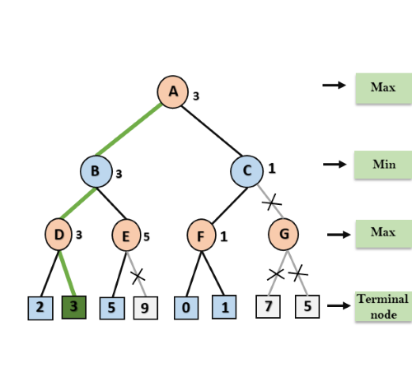

Move Ordering in Alpha-Beta pruning:

The effectiveness of alpha-beta pruning is highly dependent on the order in which each node is examined. Move order is an important aspect of alpha-beta pruning.

It can be of two types:

* **Worst ordering:** In some cases, alpha-beta pruning algorithm does not prune any of the leaves of the tree, and works exactly as minimax algorithm. In this case, it also consumes more time because of alpha-beta factors, such a move of pruning is called worst ordering. In this case, the best move occurs on the right side of the tree. The time complexity for such an order is O(bm).
* **Ideal ordering:** The ideal ordering for alpha-beta pruning occurs when lots of pruning happens in the tree, and best moves occur at the left side of the tree. We apply DFS hence it first search left of the tree and go deep twice as minimax algorithm in the same amount of time. Complexity in ideal ordering is O(bm/2).

Rules to find good ordering:

Following are some rules to find good ordering in alpha-beta pruning:

* Occur the best move from the shallowest node.
* Order the nodes in the tree such that the best nodes are checked first.
* Use domain knowledge while finding the best move. Ex: for Chess, try order: captures first, then threats, then forward moves, backward moves.
* We can bookkeep the states, as there is a possibility that states may repeat.

-------------------CONSTRAINT SATISFACTION PROBLEM(CSP)-----------REFER NOTES

# Knowledge-Based Agent in Artificial intelligence

* An intelligent agent needs **knowledge** about the real world for taking decisions and **reasoning** to act efficiently.
* Knowledge-based agents are those agents who have the capability of **maintaining an internal state of knowledge, reason over that knowledge, update their knowledge after observations and take actions. These agents can represent the world with some formal representation and act intelligently**.
* Knowledge-based agents are composed of two main parts:
  + **Knowledge-base and**
  + **Inference system**.

A knowledge-based agent must able to do the following:

* An agent should be able to represent states, actions, etc.
* An agent Should be able to incorporate new percepts
* An agent can update the internal representation of the world
* An agent can deduce the internal representation of the world
* An agent can deduce appropriate actions.

## The architecture of knowledge-based agent:

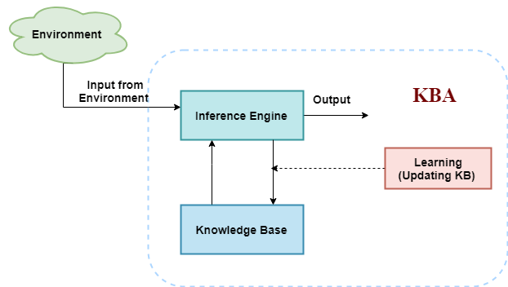

The above diagram is representing a generalized architecture for a knowledge-based agent. The knowledge-based agent (KBA) take input from the environment by perceiving the environment. The input is taken by the inference engine of the agent and which also communicate with KB to decide as per the knowledge store in KB. The learning element of KBA regularly updates the KB by learning new knowledge.

**Knowledge base:** Knowledge-base is a central component of a knowledge-based agent, it is also known as KB. It is a collection of sentences (here 'sentence' is a technical term and it is not identical to sentence in English). These sentences are expressed in a language which is called a knowledge representation language. The Knowledge-base of KBA stores fact about the world.

## Why use a knowledge base?

Knowledge-base is required for updating knowledge for an agent to learn with experiences and take action as per the knowledge.

## Inference system

Inference means deriving new sentences from old. Inference system allows us to add a new sentence to the knowledge base. A sentence is a proposition about the world. Inference system applies logical rules to the KB to deduce new information.